**By: Dominique Wiest**

**2/2025**

TABLE OF CONTENTS

**1. Bona Fide Discount Points. 3**

**2. QM vs. Non-QM Loans. 3**

**3. QM -Ability to Repay. 4**

**4. Non-QM - Ability to Repay. 5**

**5. Full Doc Loan. 6**

**6. Mortgage Insurance. 7**

**7. Prepayment Penalties. 8**

**8. HPML Loans without Appraisal 8**

**9. Prior Liens paid with Subject loan. 9**

**10. Texas Loans. 10**

**11. Delaware Subprime Loan. 11**

**12. Same Lender vs. Original Lender. 11**

**13. Streamline Loan. 12**

**14. Construction Loan Purpose. 13**

**15. Disclosure Dates. 13**

**16. Personal Property Loans 14**

**17. Counseling Certificate Rcvd Dates and Agency Type. 14**

**18. Fees. 15**

## Bona Fide Discount Points.

Loan Additional>>Compliance Information

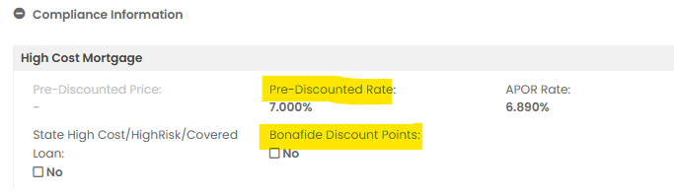

## **QM vs. Non-QM Loans.**

Loan Additional>>Compliance Information

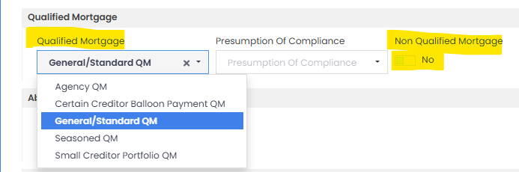

## QM -Ability to Repay.

Loan Additional>>Compliance Information

Qualified Mortgage or Exempt

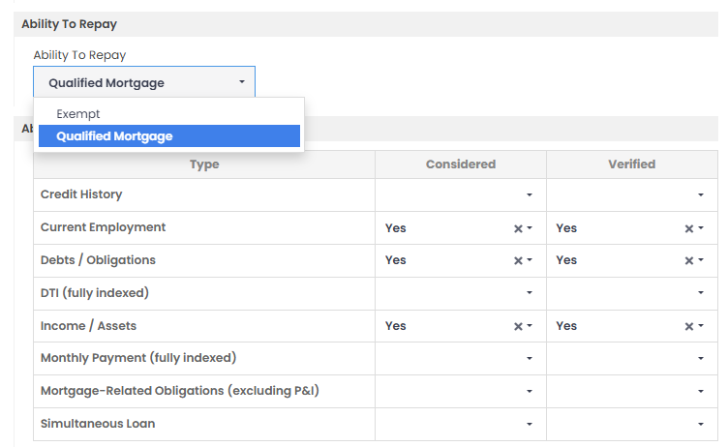

## Non-QM - Ability to Repay.

Loan Additional>>Compliance Information

General or Exempt

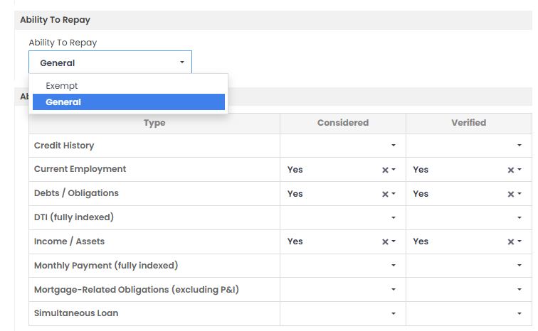

## **Full Doc Loan.**

Loan Additional>>Underwriting

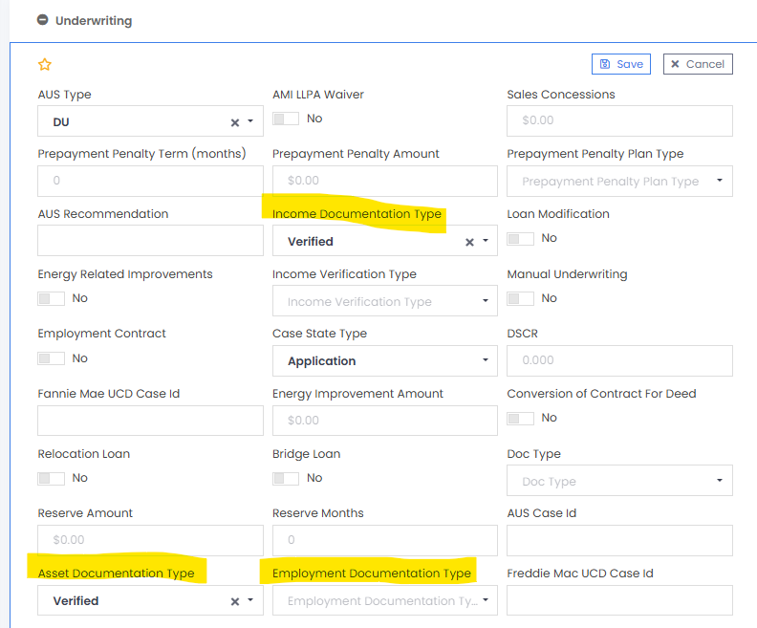

## **Mortgage Insurance.**

Loan Additional>>Mortgage Insurance

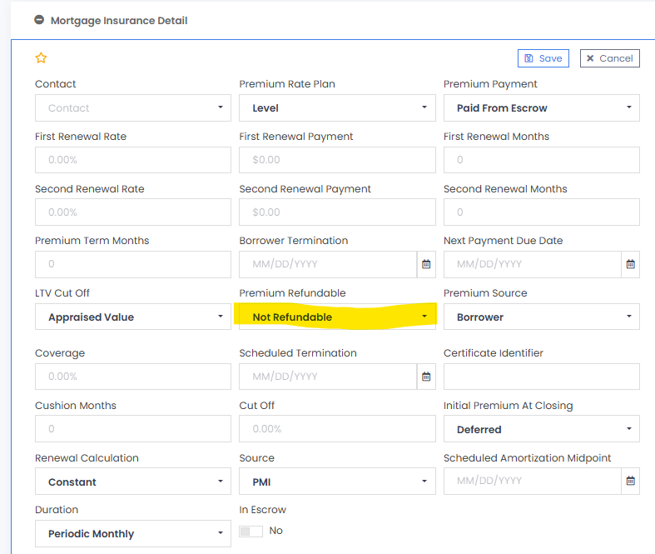

## **7. Prepayment Penalties.**

Loan Additional>>Underwriting

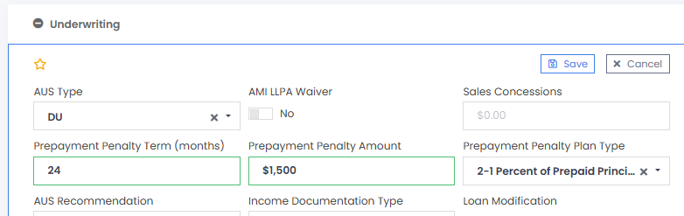

## **8. HPML Loans without Appraisal**

Loan Additional>>Compliance Information>> HPML = Yes>>

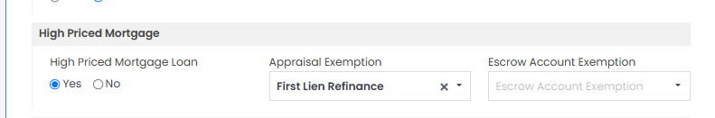

## 

## **9. Prior Liens paid with Subject loan.**

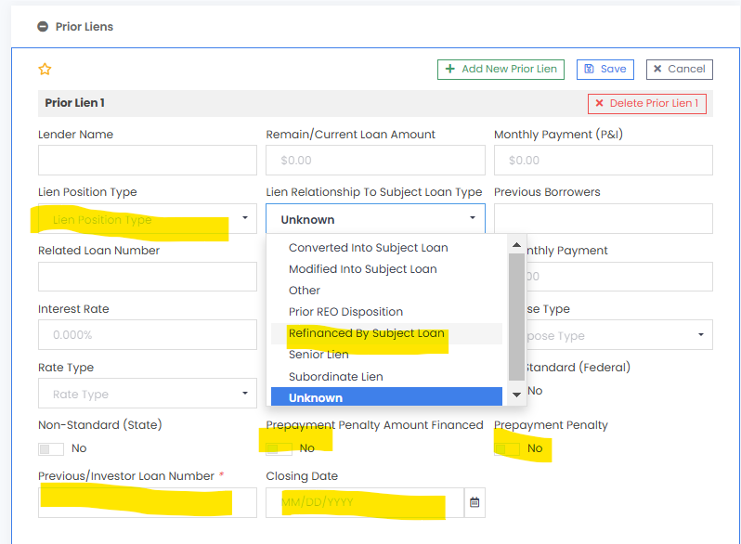

Loan Additional>>Prior Lien

## **10. Texas Loans.**

Loan Additional>>Underwriting

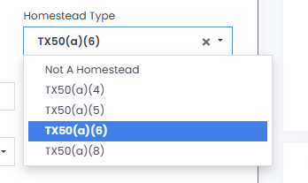

Loan Additional >>Prior Loan

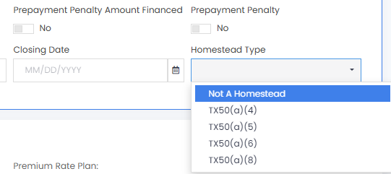

## **11. Delaware Subprime Loan.**

Loan Additional>>Compliance Information

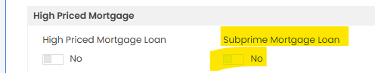

## **12. Same Lender vs. Original Lender.**

Loan Additional>>Underwriting *(soon to be Prior Lien)*

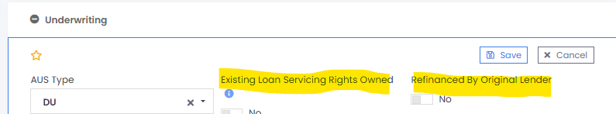

## **13. Streamline Loan.**

Loan Additional>>Underwriting

**Or**

Loan Additional>>Government Data = VA IRRRL

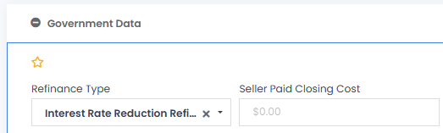

## 

## **14. Construction Loan Purpose.**

Loan Additional>>Construction

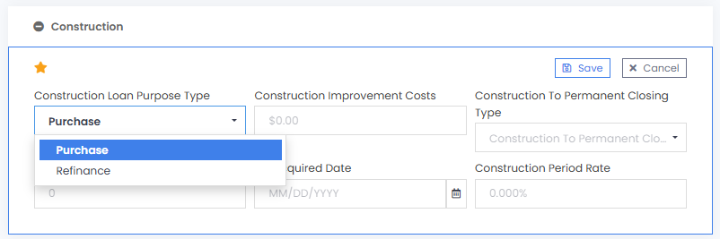

## **15. Disclosure Dates.**

Overview>>Dates>>Processing Dates - by State

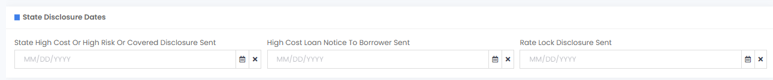

## 

## **16. Personal Property Loans**

Loan Additional>>Manufactured Home

When a Manufactured Home (with HUD seal) has not been declared real property, it is considered personal property. CIO uses the “not attached” toggle to indicate that the property is still personal property.

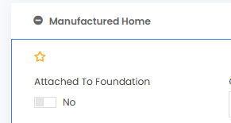

## **17. Counseling Certificate Rcvd Dates and Agency Type.**

Loan Application>>Counselings

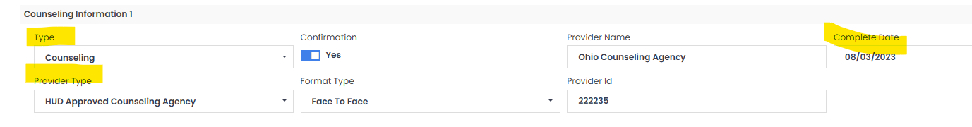

## **18. Fees**.

CIO uses Fee Types, not Fee Name, to determine how a fee is treated.

**Steps**

1. Click on Add Fee and Escrow Type

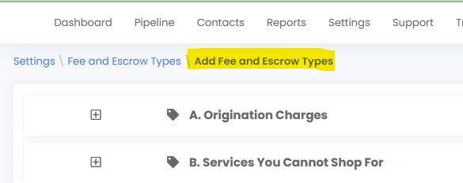

1. Choose the Fee and Click on “+” Add the fee

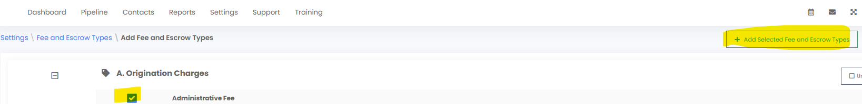

1. Return to “Fee and Escrow Types” and find your fee. Click on the pencil next to the fee name.

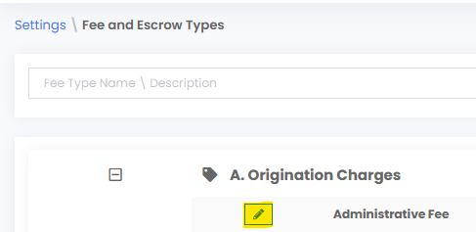

1. Notice there is a “Name” and a “Type”. CIO handles the fee based on “Type.” This step is very important because CIO runs all its fee tests based on Fee Type. The “Other Type” will automatically be included in all the fee tests because CIO assumes it is a fee that is included.

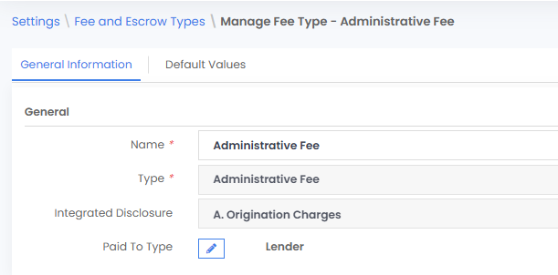

**DEMO A Loan** (Borrower Demo Loan [12-15-101]

(SC Refi w/ Balloon and PPP, Prior LoanPPP, same lender,

-Identify QM, Prior Loan, PPP, MI, Disclosure Dates)